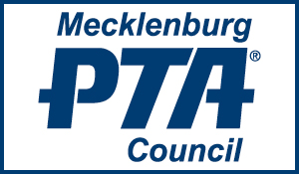

2019-2020 MEMBERSHIP FORM
With the form below, you may initiate or renew a membership in the Mecklenburg PTA Council. As we unite to advocate for all children, our voice will be louder and stronger.
Annual Dues are as Follows:
Local units with 1-149 members as of Nov. 1 $25.00
Local units with 150-499 members as of Nov. 1 $50.00
Local units with 500+ members as of Nov. 1 $75.00
Please remit dues by check made payable to Meck PTA Council (along with the form below) by November 7, 2018, and mail to:
Mecklenburg PTA Council
P.O. Box 33694
Charlotte, NC 28233

Email any questions to meckptatreasurer@gmail.com
______________________________________________________________________________
Unit Name _____________________________________ Email ______________________
Unit President __________________________________ Email ______________________
President’s Signature ____________________________________ Date _____________
# of Members _________ Amount Enclosed $___________________

