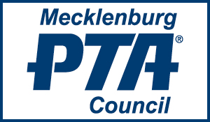

2021-2022 MEMBERSHIP FORM
This year due to the impact of COVID-19, the Meck PTA Council board has restructured the Mecklenburg PTA Council membership cost. Instead of three tiers of membership, there are only TWO tiers
Annual Dues are as Follows:
Local units with 1-149 members as of Nov. 1 $30.00
Local units with 150+ members as of Nov. 1 $50.00
Please remit dues by check made payable to Meck PTA Council (along with the form below) by November 12, 2021, and mail to:
Mecklenburg PTA Council
P.O. Box 33694
Charlotte, NC 28233

Email any questions to meckptatreasurer@gmail.com
______________________________________________________________________________
Unit Name _____________________________________ Email ______________________
Unit President __________________________________ Email ______________________
President’s Signature ____________________________________ Date _____________
# of Members _________ Amount Enclosed $___________________

